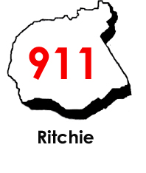

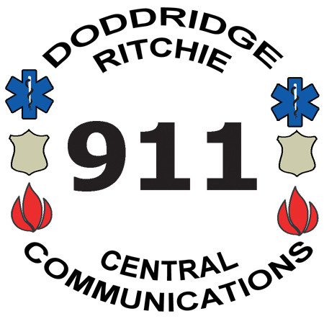
Central Communications, Inc.
4317 Lamberton Road, P.O. Box 516
Pennsboro, WV 26415
Phone: 304-659-3770 Fax: 304-659-3772
Mapping & Addressing: 304-659-2979
www.centrale911.com

Executive Director
Eric E. Ashcraft
Board of Directors
Samuel Rogers
Clinton Means
Shawn Glaspell
Steve Ritter

KEYHOLDER INFORMATION
Please fill out the following information and return it to Central Communications, Doddridge/Ritchie 911 Center, as soon as possible. Please mail forms to the 911 Center, submit by email, or hand deliver to the 911 Center. Please do not fax. Accurate information will ensure timely notification of any incidents involving your business(es). If any information changes at anytime, please contact us as soon as possible so we can have the most up to date information. The following information will be kept confidential. Please complete both front and back.

Name of Business/Residence:
Mailing Address of Bus/Res:
Physical Address of Bus/Res:
Phone Number of Bus/Res :
Hours of Operation: |  |  |  |  |  |  |  |  | Submission Date:
Owner(s) and Phone Numbers:
1) Name: |  |  |  |  |  |  |  | Home :
 |  |  | Cell : |  |  |  |  | Other :
2) Name: |  |  |  |  |  |  |  | Home :
 |  |  | Cell : |  |  |  |  | Other :
Emergency Contacts (in order of priority):
1) Name: |  |  |  |  |  |  |  | Home :
 |  |  | Cell : |  |  |  |  | Other :
2) Name: |  |  |  |  |  |  |  | Home :
 |  |  | Cell : |  |  |  |  | Other :
3) Name: |  |  |  |  |  |  |  | Home :
 |  |  | Cell : |  |  |  |  | Other :

Description of building: (Printed floor plans or drawings may be included):
If alarmed, name of alarm company & type of alarm(s):
*Please include a copy of alarm monitoring service agreement with contact information for the alarm company.
Any pertinent information regarding the property (MSDS Sheets may be included as attachments):
Fire Department Information:
Is the building equipped with automatic sprinklers?
If yes, where is the fire department connection?

Ver. 9 07/25/23

